**PROJECT WORKING SPACE**

For statement of work (SOW) and project timelines: [here](https://github.com/phamtaiece/Capstone-Sightline/blob/master/General%20Documents/SIGHTLINE_SOW%20(Final).docx)

**SLA Hardware Specification and Assembly**

**SLA – hardware:**

* 1500 OEM Rev E included:
* programmed SOM
* firmware 2.25.05 [FPGA ver. 10]
* 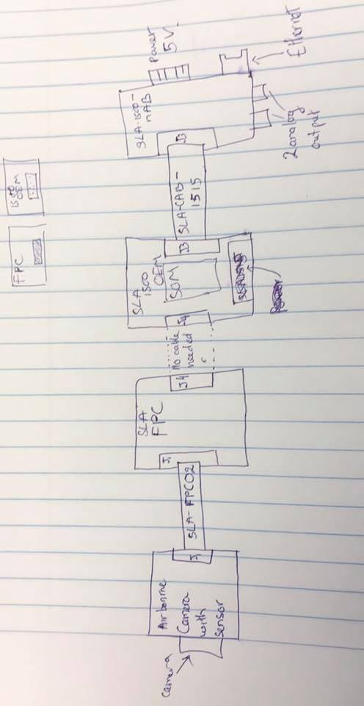license 0xFFFF
* heatsink on the top
* 1500 - SLA - nAB rev A
* 1500 - SLA-FPC Rev B
* SLA – 1500 – CASE
* Airborne camera (Mono camera) and sensor

**Assembly:**

The picture below is how pieces are connected together.

Fig 1. Basic assembly and connection

SLA-FPC 02: CABLE FFC 39 POS 0.3 MM 2” - part#: 150150239 -DigiKey

SLA-CAB-1515 – Specialize at Sightline (no part #)

J1: 39-POS, 0.3 MM – Molex – part #: 501912-3990

J4: part #: DF12B(5.0)-50DP-0.5V(86) [CONN header 50 POS 5MM SMD 0.5MM – Hirose] from 1500 OEM  
CONN RECEPT 50POS 0.5MM GOLD SMD DF12-50DS-0.5V(86) from 1500 – FPC.

J3: CONN header 14POS 1.25MM VRT SMD – Molex – Part# 53398-1471

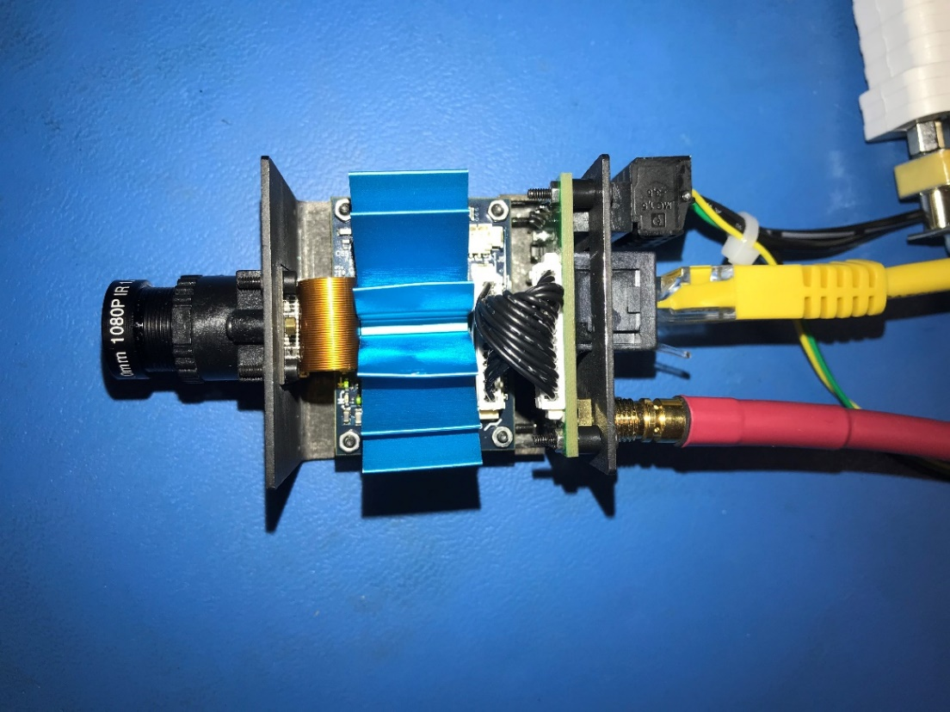

Fig 2. Assembled SLA hardware. Those external cables are: Ethernet, Analog out, and 5V power.

**The hardware has been tested successfully.**

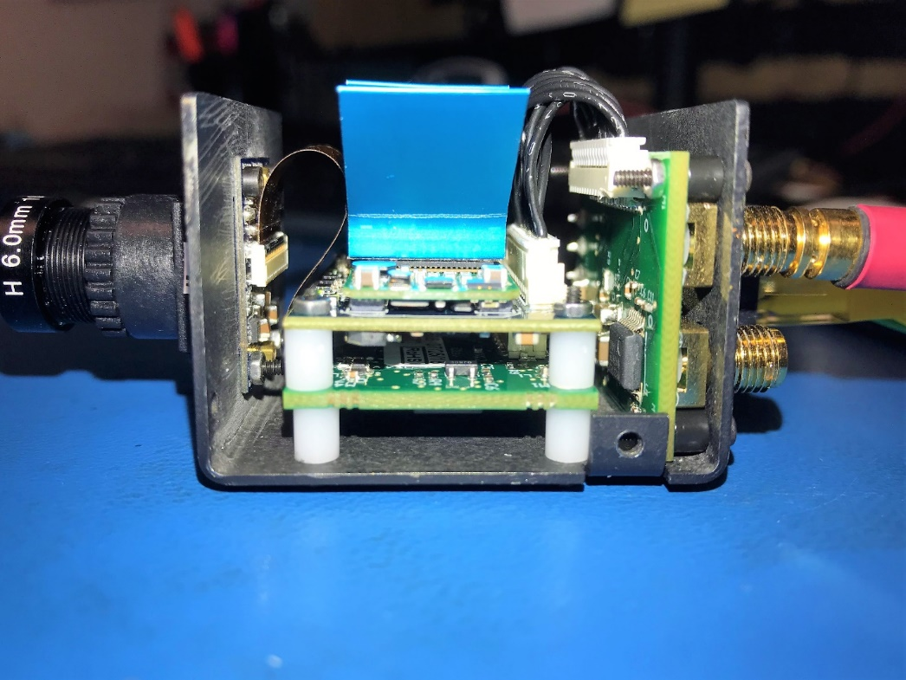

Fig 3. Assembled SLA hardware

**Pixhawk 4 Initial set up (Tai)**

Pixhawk 4 is powered from USB cable.

Issue 1: My laptop, ASUS windows 10, can’t recognize the device, Pixhawk 4. I uninstalled the software (Qgroundcontrol, PX4 driver) and installed again. It still didn’t work. The problem might come from the USB port from my laptop.

**Temporary solution:** I used Sightline’s computer to install Qgroundcontrol and PX4 driver. Yes, it works normally. The Sightline’s computer is Windows 10 pro.

**Open Qgroundcontrol:** Those initial set up and calibrate are done in Qgroundcontrol interface.

Pixhawk 4 fimware: updated to latest version.

Airframe: Calibrated

Sensor: Calibrated

**Radio:**

Error: “Detected 0 Radio Channels. To operate PX4, you need at least 5 channels.”

The Radio receiver port in Pixhawk 4: “DSM/SBUS RC 5 pin”

Tried “PPM RC” port in Pixhawk 4 -> didn’t work.

Tried a several ways to connect between Pixhawk 4 and X4R. (X4R is transmitter which is connected wirelessly to Radio Control). I haven’t figured out the problem. Plan to debug with Jeremy on Wednesday 01/30/2019

**Airframe: Quadcopter DJI Flame Wheel F450 Assembly**

**.**

**.**

**.**

**SOFTWARE**

**.**

**.**

**.**